Year 11

Literature Exam

Revision

**YEAR 11 LITERATURE – EXAM INFORMATION SEMESTER two 2021**

Your Literature exam allows **ten minutes** for reading the paper, during which time there may be NO writing, annotating or planning, followed by **three** **hours’** working time. The supervisor will inform you when you may begin working on the paper.

Blue or black pens only may be used as well as correction fluid or tape, ruler and highlighter. It is recommended you have a minimum of two pens with you in the exam. Responses written in pencil are not acceptable.

The exam is in two sections: Response/Close Reading and Extended Response.

**Section One** requires you to read one unseen poem, one unseen prose fiction extract and an extract from an unseen stage play, then respond to **one** of them in a Close Reading, ensuring you address the specific requirements of the question. Your response will be in the form of an essay and carries twenty (20) marks. The suggested working time is **sixty minutes**; this allows for both brief planning, which needs to be clearly identified as such, and your essay response.

**Section Two** presents you with eight choices of question from which you must select **two** to write well-structured essay responses, with each response carrying twenty-five (25) marks. **You must choose carefully as you cannot write on the same genre in Section Two as you have attempted in Section One.** Please ensure that all three genres - prose, poetry and drama - are addressed by the completion of the exam. You should aim to write a minimum of three pages for each essay response using sixty minutes for each- i.e. a total of one hundred and twenty minutes (two hours) for Section Two.

An effective response for any of the questions you select should include valid quotations; it is vital that you memorise words and lines from your texts in your preparation that you can then apply to the topic. Responses without illustrative evidence lack depth and conviction and this will be reflected in the mark awarded. Please do not include as evidence entire poems or large segments from the novels or plays as this merely shows your memory skills, not your ability to engage with the topic and demonstrate your understanding of the complexities of texts studied during the year. Be sensible and practical in your choices.

The exam does not simply test your knowledge of texts but your understanding of the concepts of the Literature course. Some of these include ‘reading’ in the sense of ‘present a reading of this text’, ‘how meaning is shaped’, ‘values’ and ‘attitudes’, ‘context’ in its different senses, ‘genre’, ‘language’ and words associated with the discussion of language in a literary text; ‘generic conventions’ and ‘representation’.

Good luck!

Marking keys

|  |  |
| --- | --- |
| **Description Close reading** | **Marks** |
| **Reading/s of text**  The response presents: | |
| a sophisticated response using appropriate reading strategies, making a detailed analysis of language and/or generic conventions. | 7 |
| a perceptive reading making a detailed analysis of language and/or generic conventions. | 6 |
| an informed reading, making relevant reference to language and/or generic conventions. | 5 |
| a general reading that makes some valid points about language and/or generic conventions. | 4 |
| an inconsistent reading making some reference to language and/or generic conventions. | 3 |
| a vague reading with little reference to language and generic conventions. | 2 |
| a limited reading showing little understanding of the text. | 1 |
| no evidence of this criterion. | 0 |
| **Subtotal** | **7** |
| **Use of evidence to support a reading/s** The response uses: | |
| strategic and critical use of quotation, with pertinent examples from the text and appropriate reference to cultural contexts used to strongly develop the reading. | 6 |
| appropriate and effective use of quotation, with appropriate examples from the text and relevant reference to cultural contexts that develop the reading. | 5 |
| some appropriate quotation, with valid examples from the text that largely develop the reading. | 4 |
| some quotation, with relevant examples from the text, that generally develop the reading. | 3 |
| few relevant quotes, with few relevant examples from the text, and that do• not always develop the reading. | 2 |
| limited supporting evidence. | **1** |
| no evidence of this criterion. | 0 |
| **Subtotal** | **6** |
| Literary concepts and literary terms  t h responsee.' demonstrates.. | |
| comprehensive understanding of literary concepts and sophisticated use of literary terminology related to the reading. | 6 |
| informed understanding of literary concepts and competent use of literary terminology related to the reading. | 5 |
| sound understanding of literary concepts and detailed use of literary terminology related to the reading. | 4 |
| some understanding of literary concepts and some use of literary terminology related to the reading. | 3 |
| limited understanding of literary concepts and infrequent use of literary terminology. | 2 |
| little understanding of literary concepts and limited use of literary terminology. | 1 |
| no evidence of this criterion. | 0 |
| **Subtotal** | **6** |
| **Expression of ideas**  The response expresses ideas: | |
| in a controlled argument and structure and with sophisticated language use and style. | 6 |
| in a coherent argument and structure and sustained style. | 5 |
| in a purposeful and/or methodical style. | 4 |
| In a largely clear way, but not always coherently structured. | 3 |
| in a disjointed style, characterised by unclear language use. | 2 |
| that are difficult to follow because of unclear language use and lack of structure. | 1 |
| no evidence of this criterion. | 0 |
| **Subtotal** | **6** |
| **Overall total** | **25** |

Section 2

|  |  |
| --- | --- |
| **Description** | **Marks** |
| **Engagement with the question** The response demonstrates: | |
| a sophisticated and critical engagement with all parts of the question. | 6 |
| a comprehensive, analytical and detailed engagement with all parts of the question. | 5 |
| a purposeful engagement with all parts of the question. | 4 |
| a general engagement with most parts of the question. | 3 |
| a limited or simplistic engagement with the question. | 2 |
| little or no engagement with the question. | 1 |
| no evidence of this criterion. | 0 |
| **Subtotal** | **6** |
| **Use of textual knowledge and understandings** The response shows: | |
| a comprehensive, critical and detailed understanding of the selected text/s. | 6 |
| a purposeful and analytical understanding of the selected text/s. | 5 |
| a sound and detailed understanding of the selected text/s. | 4 |
| a general understanding of the selected text/s. | 3 |
| some understanding of the selected text/s. | 2 |
| limited understanding of the selected text/s. | 1 |
| no evidence of this criterion. | 0 |
| **Subtotal** | **6** |
| **Use of evidence** The response uses: | |
| strategic and critical use of quotation, with pertinent examples from the text and appropriate reference to cultural contexts used to support the answer. | 4 |
| appropriate quotation, with relevant examples from the text and some relevant reference to cultural contexts to support the answer. | 3 |
| some quotation, with some relevant examples from the text. | 2 |
| few relevant quotes or few relevant examples from the text. | 1 |
| no evidence of this criterion. | 0 |
| **Subtotal** | **4** |
| **Literary concepts and literary terms** The response demonstrates: | |
| well-informed understanding of literary discourse, literary concepts and sophisticated use of literary terminology related to the question. | 4 |
| sound understanding of literary discourse, literary concepts and competent use of literary terminology related to the question. | 3 |
| general understanding of literary concepts and use of appropriate terminology related to the question. | 2 |
| some understanding of literary concepts and some use of appropriate literary terminology related to the question. | 1 |
| no evidence of this criterion. | 0 |
| **Subtotal** | **4** |
| **Expression of ideas**  The response demonstrates: | |
| a controlled argument and structure, and sophisticated language and style. | 5 |
| a coherent argument and structure, and fluent style. | 4 |
| clear and literate expression, and a largely coherent structure. | 3 |
| mostly clear expression and some structure. | 2 |
| unclear expression and a lack of structure. | 1 |
| no evidence of this criterion | 0 |
| **Subtotal** | **5** |
| **Overall total** | **25** |

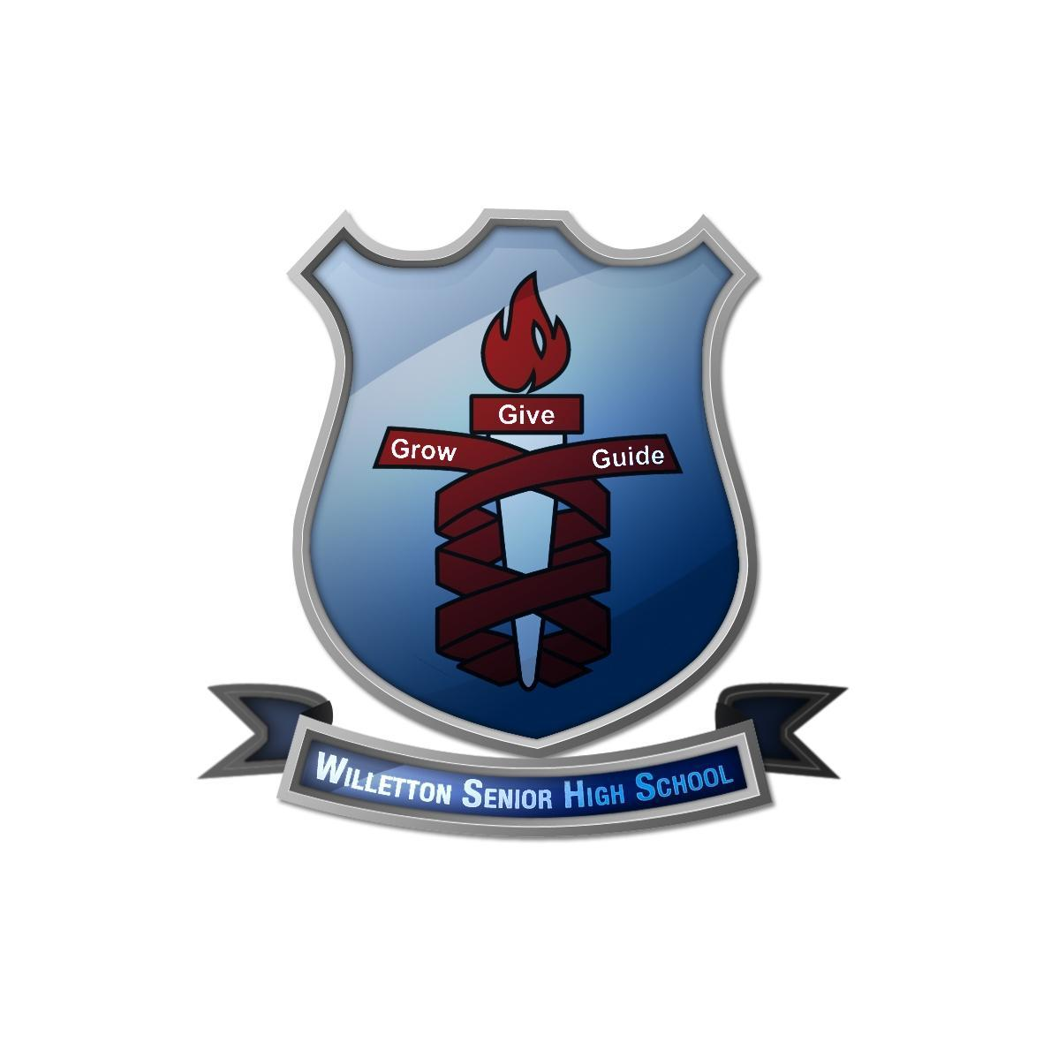

**Willetton Senior**

**High School**

**Mock EXAMINATION**

**QUESTION PAPER**

# LITERATURE Year 11

**TIME ALLOWED FOR THIS PAPER**

Reading time before commencing: Ten minutes

Working time for paper: Three hours

**MATERIALS REQUIRED/RECOMMENDED FOR THIS PAPER**

*TO BE PROVIDED BY THE SUPERVISOR*

This Question Paper

Answer Booklets

*TO BE PROVIDED BY THE CANDIDATE*

Standard Items: Pens, correction tape/fluid, highlighters

Special Items: Nil

**IMPORTANT NOTE TO CANDIDATES**

**STRUCTURE OF THIS PAPER**

|  |  |  |  |  |  |
| --- | --- | --- | --- | --- | --- |
| Section | Suggested working time  (in minutes) | Number of questions available | Number of questions to be attempted | Marks  Available | Percentage of exam |
| **Section One:** Response –  Close reading | 60 | 1 | 1 | 25 | 30 |
| **Section** **Two**:  Extended Response | 120 | 9 | 2 | 50 | 70 |
|  |  |  |  | Total | 100 |

**Instructions to Candidates**

1. The rules for the conduct of Western Australian external examinations are detailed in the *WACE Manual*. Sitting this examination implies that you agree to abide by these rules.
2. Write your responses in the Standard Answer Book or paper supplied by your school or college.
3. This examination requires you to refer to literary texts studied this year. The text(s) discussed in Section Two as the primary references(s) must be from the text lists in the syllabus.
4. This examination requires you to respond to three questions. Each response must make primary reference to a different genre (prose, poetry and drama). In Section Once if you make reference to:
   * 1. Text A (poetry), then in Section Two you must respond to two questions, one response making primary reference to prose and the other to drama.
     2. Text B (prose), then in Section Two you must respond to two questions, one response making reference to poetry and the other to drama.
     3. Text C (drama), then in Section Two you must respond to two questions, one response making reference to poetry and other to prose.
5. If you make primary reference to the same genre twice, then 15 percent will be deducted from your total raw examination mark for Literature.
6. If you choose one of the three questions that makes reference to a specific genre, you must write on that genre, otherwise 15 percent will be deducted from your total raw examination mark for Literature.
7. For each response that you write in Section Two, indicate the question number and the genre (poetry, prose or drama) that you are using as your primary reference. You must not write on the same question twice.
8. You must be careful to confine your responses to the specific questions asked and to follow any instructions that are specific to a particular question.

**Example**

**Questions**

**Section 2**

**SECTION TWO: EXTENDED RESPONSE (50 marks)**

This section has **nine (9)** questions. You are required to respond to **two (2)** questions. Each response must make primary reference to a different genre from that used in Section One. If you make reference in Section One to:

1. Text A (poetry), then in this section one response must make primary reference to prose and one response must make primary reference to drama.
2. Text B (prose), then in this section one response must make primary reference to poetry and one response must make primary reference to drama.
3. Text C (drama), then in this section one response must make primary reference to prose and one response must make primary reference to poetry.

**Suggested working time: 120 minutes**

________________________________________________________________________

**Question 2 (25 marks)**

With detailed reference to one text you have studied this semester, explain how it reflects the cultural values important at its time of production.

**Question 3 (25 marks)**

Discuss how the themes of conflict **or** power **or** desire have been explored in a text studied this semester.

**Question 4 (25 marks)**

Discuss the ways in which texts can make unfamiliar experience available to us. Refer to one or more texts studied this semester.

**Question 5 (25 marks)**

Some literary texts use oppositions (such as light/dark, good/evil, and man/animal) to explore the nature of human existence. Discuss this statement with reference to one or more texts you have studied this semester.

**Question 6 (25 marks)**

Discuss the representation of race **or** gender in at least one text you have studied this semester.

**Question 7 (25 marks)**

Discuss the ways in which narrative point of view or persona positions the reader to respond to one or more texts.

**Question 8 (25 marks)**

Discuss the important of place in the novel *The Secret River.*

**Question 9 (25 marks)**

How are three poetic techniques used to communicate a theme in one or more poems studied this semester?

**Question 10 (25 marks)**

Conflict is the basis of all good theatre. How is conflict used to engage the audience with one or more ideas in *Macbeth?*

_______________________________________________________________________

**Question 2 (20 marks)**

Explain how a text you have studied has explored a central idea using a particular time, society or culture.

**Question 3 (20 marks)**

Explain the impact of structure on shaping meaning in one or more studied texts.

**Question 4 (20 marks)**

Examine how the theme of love is explored in one or more studied texts.

**Question 5 (20 marks)**

Writers adopt or adapt the conventions of genre to suit their purpose in the texts that

they produce. Show how this occurs in a text studied this year.

**Question 6 (20 marks)**

The persona or narrator of a text affects readers in a particular way. Discuss with

reference to one or more texts.

**Question 7 (20 marks)**

Discuss how language shapes meaning in one or more poemsyou have studied**.**

**Question 2 (20 marks)**

Explain how a text you have studied has explored a central idea using a particular time, society or culture.

**Question 3 (20 marks)**

Explain the impact of structure on shaping meaning in one or more studied texts.

**Question 4 (20 marks)**

Examine how the theme of love is explored in one or more studied texts. •

**Question 5 (20 marks)**

**\**Writers adopt or adapt the conventions of genre to suit their purpose in the texts that they produce. Show how this occurs in a text studied this year.

**Question 6 (20 marks)**

The persona or narrator of a text affects readers in a particular way. Discuss with reference to one or more texts.

**Question 7 (20 marks)**

Discuss how language shapes meaning in one or more poems you have studied.

Text revision table

|  |  |  |  |  |  |
| --- | --- | --- | --- | --- | --- |
| **TEXT** | **Text**  **type** | **Genre** | **Course ideas being assessed**  **Key terminology** | **Values endorsed or challenged** | **Conventions to discuss** |
| The Secret River | Novel | Prose |  | . |  |
| Frankenstein | Novel | Prose |  |  |  |
| Wagan Watson | Poem | Poetry |  |  |  |
| Poetry 19th Century | Poem | Poetry |  |  |  |
| Macbeth | Script | Drama |  |  |  |
| Dead White Males | Script | Drama |  |  |  |

Close reading section 1

**SECTION ONE Poetry texts**

|  |
| --- |
| TECHNIQUES |
| TITLE  SPEAKER  Poet?\Narrator?  Observer? |
| CONTEXT— when was it written? What was society like? Does the authors personal context affect the meaning? |
| READINGS  WHAT READINGS CAN YOU APPLY TO THIS POEM?   * Traditional Literary Criticism * Formalism and New Criticism * Marxism Postcolonial Criticism * Gender Studies and Queer Theory |
| TYPE OF POEM  FORM  Traditional or Unique  Stanzas  Pattern  Shape of stanzas |
| SOUNDS OF WORDS  Alliteration  Assonance  Onomatopoeia  Repetition •  Soft sounds/.hard sounds |
| SOUND DEVICES  Rhyme  Rhythm  Metre  Regular or irregular |
| IMAGERY  Personification  Metaphor  Simile  Symbols |

The poem ‘We are going’ by the Aboriginal Australian poet Oodgeroo Noonuccal, who was a leader in the struggle for Aboriginal rights in Australia. “We Are Going” was published in Noonuccal’s 1964 collection of the same name, the first book of poetry to be published by an Aboriginal Australian poet.

**We are Going**  
They came in to the little town  
A semi-naked band subdued and silent  
All that remained of their tribe.  
They came here to the place of their old bora ground  
Where now the many white men hurry about like ants.  
Notice of the estate agent reads: 'Rubbish May Be Tipped Here'.  
Now it half covers the traces of the old bora ring.  
'We are as strangers here now, but the white tribe are the strangers.  
We belong here, we are of the old ways.  
We are the corroboree and the bora ground,  
We are the old ceremonies, the laws of the elders.  
We are the wonder tales of Dream Time, the tribal legends told.  
We are the past, the hunts and the laughing games, the wandering camp fires.  
We are the lightening bolt over Gaphembah Hill  
Quick and terrible,  
And the Thunderer after him, that loud fellow.  
We are the quiet daybreak paling the dark lagoon.  
We are the shadow-ghosts creeping back as the camp fires burn low.  
We are nature and the past, all the old ways  
Gone now and scattered.  
The scrubs are gone, the hunting and the laughter.  
The eagle is gone, the emu and the kangaroo are gone from this place.  
The bora ring is gone.  
The corroboree is gone.  
And we are going.'

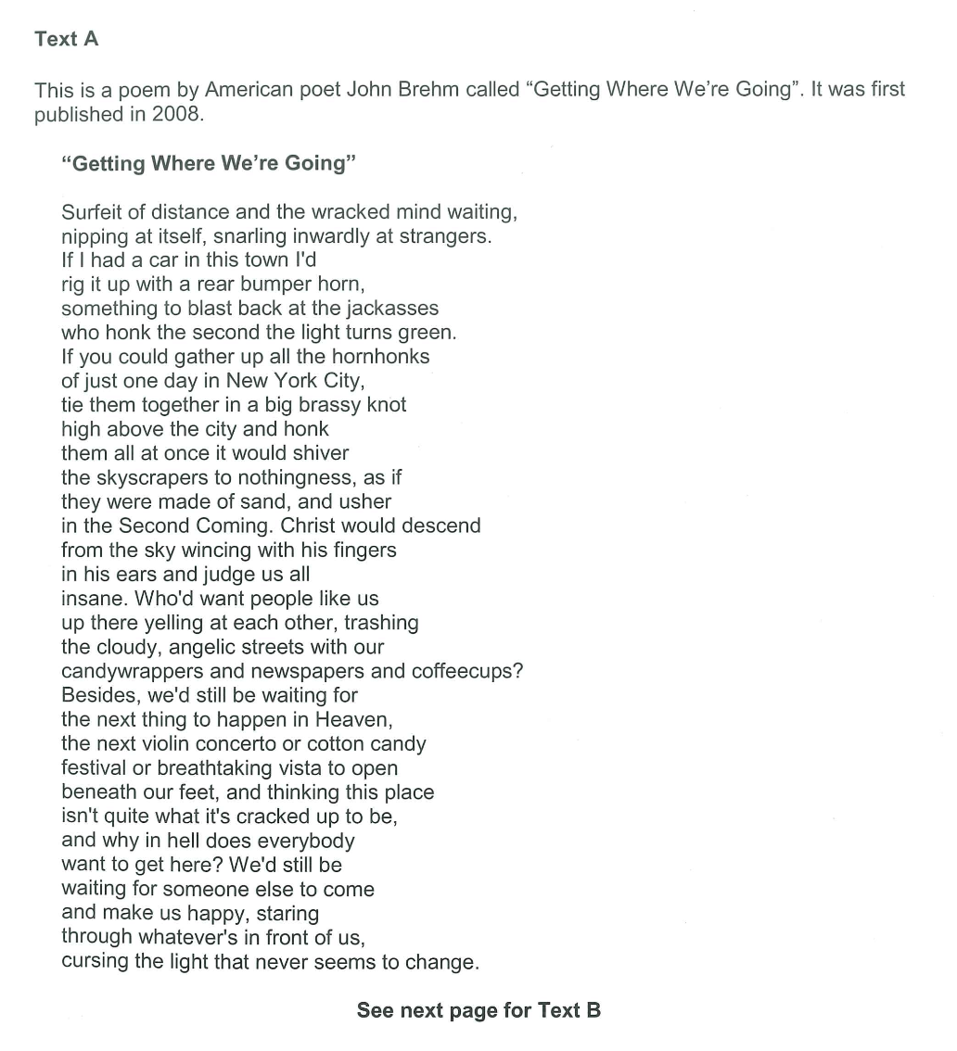



26

### I look at the world a protest poem by Langston Hughes

BY [LANGSTON HUGHES](https://www.poetryfoundation.org/poets/langston-hughes)

I look at the world

From awakening eyes in a black face—

And this is what I see:

This fenced-off narrow space

Assigned to me.

I look then at the silly walls

Through dark eyes in a dark face—

And this is what I know:

That all these walls oppression builds

Will have to go!

I look at my own body

With eyes no longer blind—

And I see that my own hands can make

The world that's in my mind.

Then let us hurry, comrades,

The road to find.

**Narrative conventions**

Characterisation

Setting

Structure

Syntax

Tone

Style

Dialogue

Emotive language

Descriptive language

Narration

Metaphors

Similes

Personification

Hyperbole

Imagery

Allusion

Symbolism

Diction

Repetition

**Characterisation**

Characterisation is important to analyse in a text as it reveals a lot about the message of the text. The

characters are usually the vessel by which the author tells the story. Are the characters typical of a genre?

Do they fit a certain archetype? Are some characters good and some evil?

* Speech
* Actions
* Appearance
* others

**Dialogue**

Dialogue is anytime that someone speaks within your narrative. It can be very telling about a number of

things and can reveal things about your characters, in a different way to your narrator

**Setting**

An understanding of setting will assist you with all different types of narrative texts. In certain genres such as wester and horror, the setting is very fundamental. However, no matter the text, the setting is going to play a key role

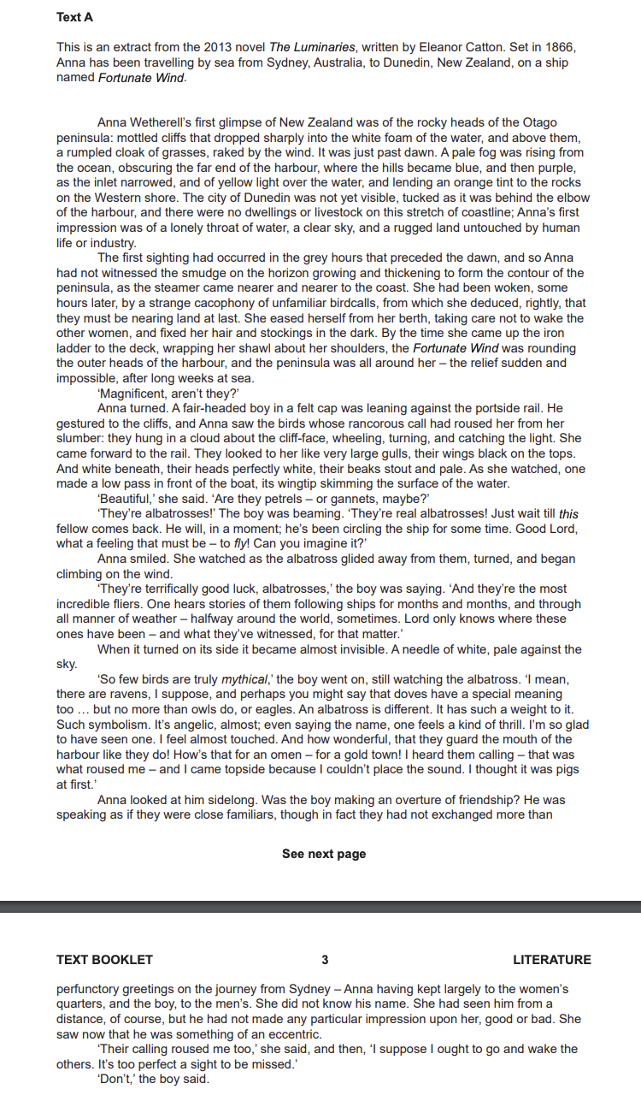.

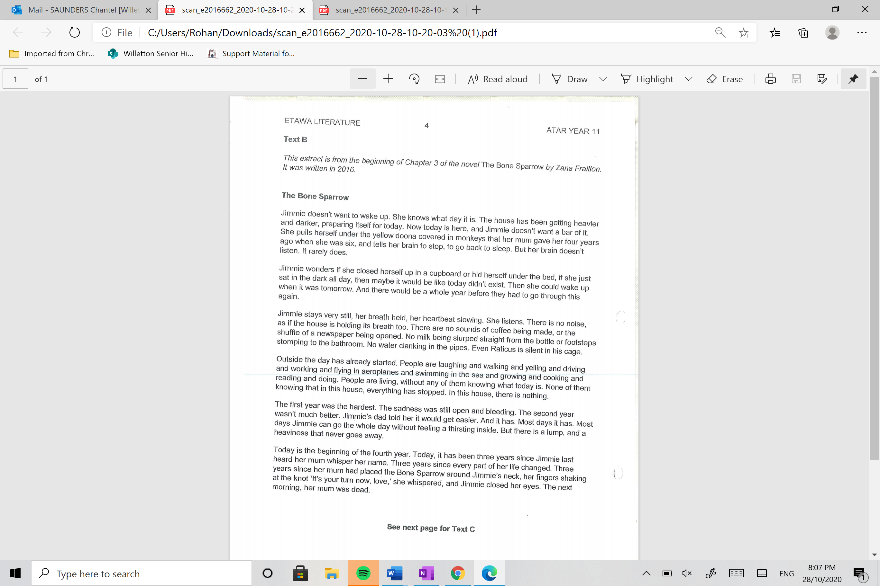

**Drama texts**

